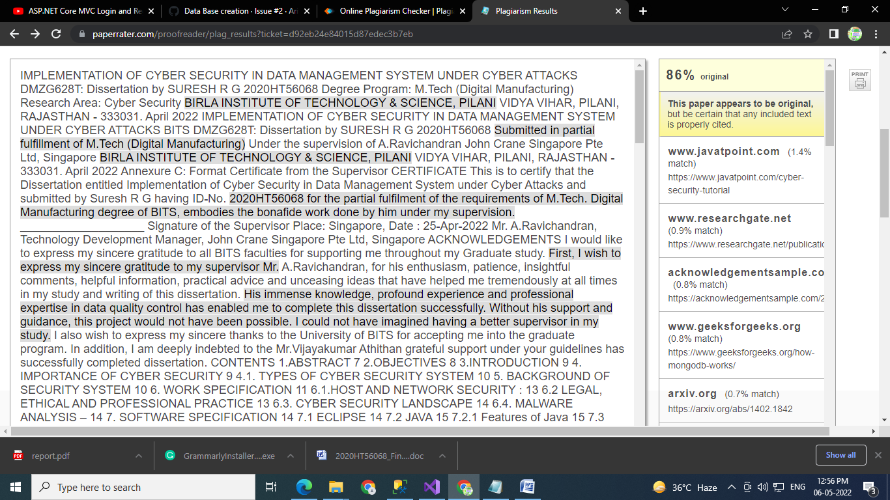

Link checked through this link :

<https://www.paperrater.com/proofreader/plag_results?ticket=d92eb24e84015d87edec3b7eb>

**86%  original**

**This paper appears to be original,** but be certain that any included text is properly cited.

[**www.javatpoint.com**](https://www.javatpoint.com/cyber-security-tutorial)   (1.4% match)

<https://www.javatpoint.com/cyber-security-tutorial>

[**www.researchgate.net**](https://www.researchgate.net/publication/277718176_Cyber_Security_and_the_Internet_of_Things_Vulnerabilities_Threats_Intruders_and_Attacks)   (0.9% match)

[https://www.researchgate.net/publication/277718...](https://www.researchgate.net/publication/277718176_Cyber_Security_and_the_Internet_of_Things_Vulnerabilities_Threats_Intruders_and_Attacks)

[**acknowledgementsample.com**](https://acknowledgementsample.com/2020/02/12/sample-acknowledgement-for-a-final-year-project/)   (0.8% match)

[https://acknowledgementsample.com/2020/02/12/sa...](https://acknowledgementsample.com/2020/02/12/sample-acknowledgement-for-a-final-year-project/)

[**www.geeksforgeeks.org**](https://www.geeksforgeeks.org/how-mongodb-works/)   (0.8% match)

<https://www.geeksforgeeks.org/how-mongodb-works/>

[**arxiv.org**](https://arxiv.org/abs/1402.1842)   (0.7% match)

<https://arxiv.org/abs/1402.1842>

[**www.bartleby.com**](https://www.bartleby.com/essay/Research-in-Network-Infrastructure-F3VTGSS8C38Q)   (0.7% match)

[https://www.bartleby.com/essay/Research-in-Netw...](https://www.bartleby.com/essay/Research-in-Network-Infrastructure-F3VTGSS8C38Q)

[**www.guru99.com**](https://www.guru99.com/java-platform.html)   (0.7% match)

<https://www.guru99.com/java-platform.html>

[**arxiv.org**](https://arxiv.org/abs/1402.1842)   (0.6% match)

<https://arxiv.org/abs/1402.1842>

[**www.bartleby.com**](https://www.bartleby.com/essay/Sample-Resume-Competency-Planner-P3U5CLL2LBQW)   (0.5% match)

[https://www.bartleby.com/essay/Sample-Resume-Co...](https://www.bartleby.com/essay/Sample-Resume-Competency-Planner-P3U5CLL2LBQW)

[**gsdec.network**](https://gsdec.network/8484/cybersecurity-and-financial-crimes-2/)   (0.5% match)

[https://gsdec.network/8484/cybersecurity-and-fi...](https://gsdec.network/8484/cybersecurity-and-financial-crimes-2/)

[**gsdec.network**](https://gsdec.network/8484/cybersecurity-and-financial-crimes-2/)   (0.5% match)

[https://gsdec.network/8484/cybersecurity-and-fi...](https://gsdec.network/8484/cybersecurity-and-financial-crimes-2/)

[**www.brainia.com**](https://www.brainia.com/essays/English-Test/453645.html)   (0.5% match)

[https://www.brainia.com/essays/English-Test/453...](https://www.brainia.com/essays/English-Test/453645.html)

[**www.termpaperwarehouse.com**](https://www.termpaperwarehouse.com/essay-on/Comp/472991)   (0.5% match)

[https://www.termpaperwarehouse.com/essay-on/Com...](https://www.termpaperwarehouse.com/essay-on/Comp/472991)

[**www.studymode.com**](https://www.studymode.com/essays/Should-The-Business-Move-To-The-39007579.html)   (0.5% match)

[https://www.studymode.com/essays/Should-The-Bus...](https://www.studymode.com/essays/Should-The-Business-Move-To-The-39007579.html)

[**www.slideshare.net**](https://www.slideshare.net/MohammedAli187/200718ts146)   (0.4% match)

[https://www.slideshare.net/MohammedAli187/20071...](https://www.slideshare.net/MohammedAli187/200718ts146)

[**www.bartleby.com**](https://www.bartleby.com/essay/Sample-Resume-Competency-Planner-P3U5CLL2LBQW)   (0.4% match)

[https://www.bartleby.com/essay/Sample-Resume-Co...](https://www.bartleby.com/essay/Sample-Resume-Competency-Planner-P3U5CLL2LBQW)

[**www.studymode.com**](https://www.studymode.com/essays/supply-chain-logistic-solution-1345907.html)   (0.4% match)

[https://www.studymode.com/essays/supply-chain-l...](https://www.studymode.com/essays/supply-chain-logistic-solution-1345907.html)

[**www.slideshare.net**](https://www.slideshare.net/MohammedAli187/200718ts146)   (0.4% match)

[https://www.slideshare.net/MohammedAli187/20071...](https://www.slideshare.net/MohammedAli187/200718ts146)

[**www.antiessays.com**](https://www.antiessays.com/free-essays/Literature-Review-On-Material-Management-And-288353.html)   (0.4% match)

[https://www.antiessays.com/free-essays/Literatu...](https://www.antiessays.com/free-essays/Literature-Review-On-Material-Management-And-288353.html)

[**www.termpaperwarehouse.com**](https://www.termpaperwarehouse.com/essay-on/Management-Audit/137258)   (0.4% match)

[https://www.termpaperwarehouse.com/essay-on/Man...](https://www.termpaperwarehouse.com/essay-on/Management-Audit/137258)

[**www.studymode.com**](https://www.studymode.com/essays/Credit-Risk-In-Bank-1359216.html)   (0.4% match)

[https://www.studymode.com/essays/Credit-Risk-In...](https://www.studymode.com/essays/Credit-Risk-In-Bank-1359216.html)

[**www.studymode.com**](https://www.studymode.com/essays/Protein-Delivery-Through-Oral-Route-1917987.html)   (0.3% match)

[https://www.studymode.com/essays/Protein-Delive...](https://www.studymode.com/essays/Protein-Delivery-Through-Oral-Route-1917987.html)

[**www.slideshare.net**](https://www.slideshare.net/MohammedAli187/200718ts146)   (0.3% match)

[https://www.slideshare.net/MohammedAli187/20071...](https://www.slideshare.net/MohammedAli187/200718ts146)

[**www.studymode.com**](https://www.studymode.com/essays/Protein-Delivery-Through-Oral-Route-1917987.html)   (0.3% match)

[https://www.studymode.com/essays/Protein-Delive...](https://www.studymode.com/essays/Protein-Delivery-Through-Oral-Route-1917987.html)

[**www.termpaperwarehouse.com**](https://www.termpaperwarehouse.com/essay-on/Information-In-The-Modern-Enterprise/209069)   (0.3% match)

[https://www.termpaperwarehouse.com/essay-on/Inf...](https://www.termpaperwarehouse.com/essay-on/Information-In-The-Modern-Enterprise/209069)

[**www.bartleby.com**](https://www.bartleby.com/essay/Process-Description-Of-Object-Oriented-Programming-P3GR3CC42LBWQ)   (0.3% match)

[https://www.bartleby.com/essay/Process-Descript...](https://www.bartleby.com/essay/Process-Description-Of-Object-Oriented-Programming-P3GR3CC42LBWQ)

[**www.termpaperwarehouse.com**](https://www.termpaperwarehouse.com/essay-on/Term-Paper/105707)   (0.2% match)

[https://www.termpaperwarehouse.com/essay-on/Ter...](https://www.termpaperwarehouse.com/essay-on/Term-Paper/105707)

[**www.bartleby.com**](https://www.bartleby.com/essay/Teaching-Interventions-F3TXKZU6P9P)   (0.2% match)

[https://www.bartleby.com/essay/Teaching-Interve...](https://www.bartleby.com/essay/Teaching-Interventions-F3TXKZU6P9P)

[**www.studymode.com**](https://www.studymode.com/essays/Should-The-Business-Move-To-The-39007579.html)   (0.2% match)

[https://www.studymode.com/essays/Should-The-Bus...](https://www.studymode.com/essays/Should-The-Business-Move-To-The-39007579.html)

[**en.wikipedia.org**](https://en.wikipedia.org/wiki?curid=12641705)   (0.2% match)

<https://en.wikipedia.org/wiki?curid=12641705>

[**www.bartleby.com**](https://www.bartleby.com/essay/Relational-Database-Management-System-Rdbms-P346WGQ3FVDX)   (0.2% match)

[https://www.bartleby.com/essay/Relational-Datab...](https://www.bartleby.com/essay/Relational-Database-Management-System-Rdbms-P346WGQ3FVDX)

NOTE: redundant sources may not be shown.

[https://assets.paperrater.com/images/icons/print.png](https://www.paperrater.com/proofreader/proof_results?ticket=d92eb24e84015d87edec3b7eb&print=true)